● Explain Continuous Integration
Continuous Integration (CI) is a software development practice where developers regularly merge their code changes into a central repository, after which automated builds and tests are run.
Key aspects of Continuous Integration:
- Frequent Code Commits: Developers integrate code into a shared repository multiple times a day
- Automated Builds: Each integration is verified by an automated build to detect errors quickly
- Automated Testing: Unit tests and integration tests run automatically to catch bugs early
- Immediate Feedback: Teams get immediate feedback on their code changes
- Version Control Integration: All code is maintained in a version control system (like Git)
Benefits:
- Early detection of integration bugs
- Reduced integration problems
- Faster feedback on code quality
- Improved software quality
- Reduced deployment risks

● Why Jenkins is popular? Mention advantages.
Jenkins is an open-source automation server widely used for Continuous Integration and Continuous Delivery (CI/CD).
Reasons for Jenkins' popularity:
- Open Source: Free to use with a large community support
- Plugin Ecosystem: Over 1000+ plugins available for various tools and integrations
- Easy Installation: Simple to set up and configure
- Platform Independent: Runs on Windows, Linux, and macOS
- Distributed Builds: Supports master-slave architecture for load distribution

Advantages of Jenkins:
Advantage | Description
Extensibility | Rich plugin ecosystem allows integration with almost all DevOps tools
Pipeline as Code | Supports declarative and scripted pipelines using Jenkinsfile
Community Support | Large community provides extensive documentation and support
Flexibility | Can build, test, and deploy any type of project
Easy Configuration | Web-based interface for easy setup and management
Distributed Builds | Can distribute work across multiple machines
Built-in Features | Scheduling, monitoring, and notifications out of the box
Integration | Works with Git, Maven, Gradle, Docker, Kubernetes, and more

Python Installation
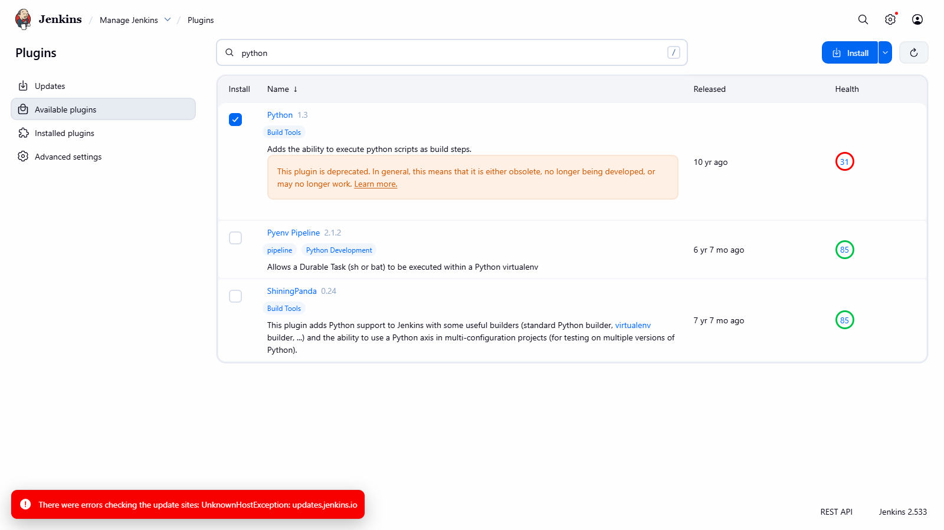

Implicit Function
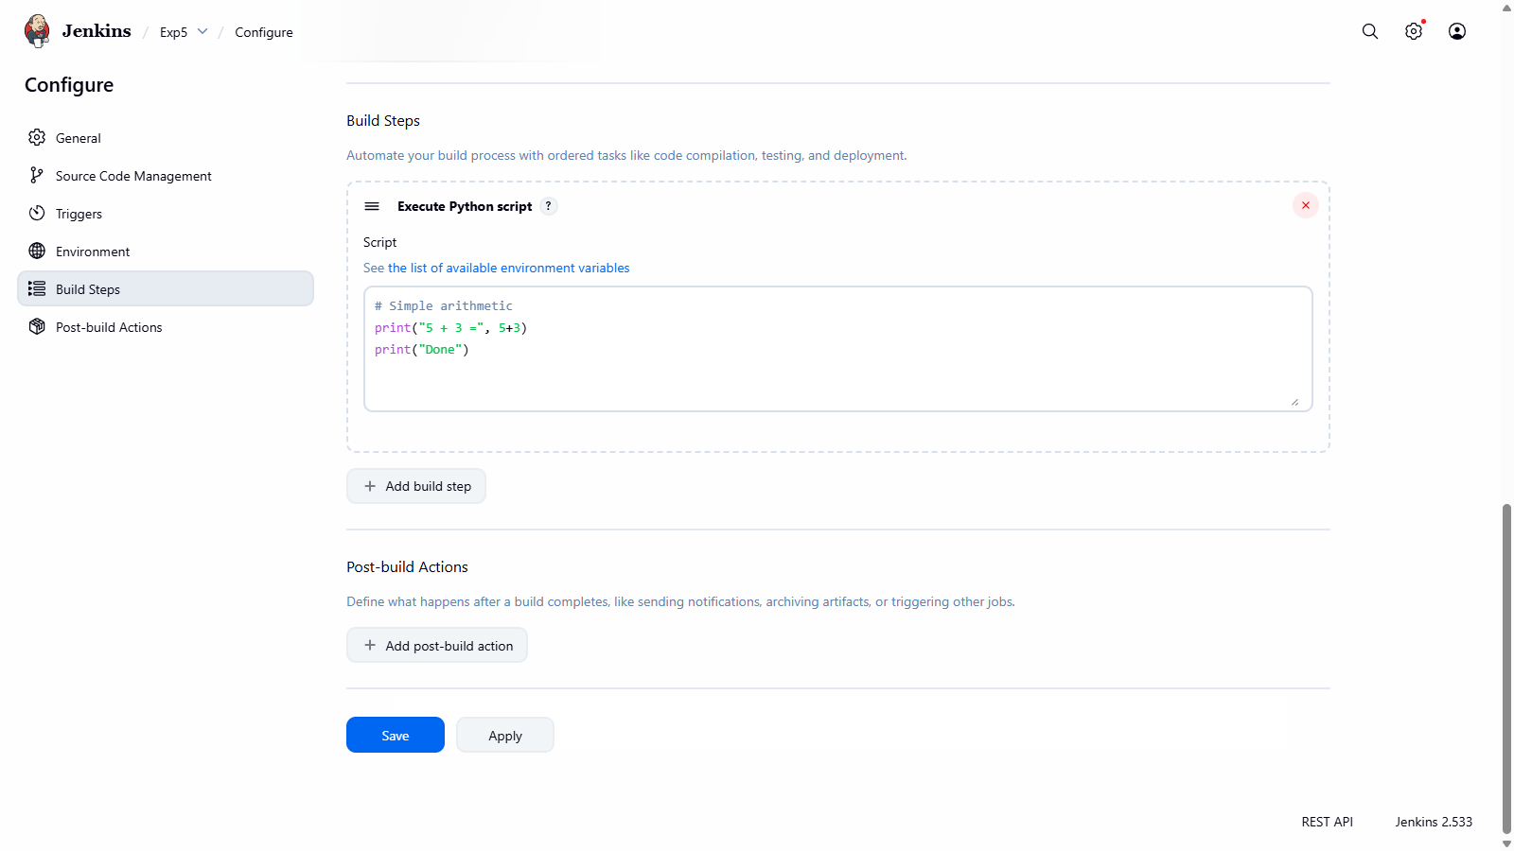

Console Output:

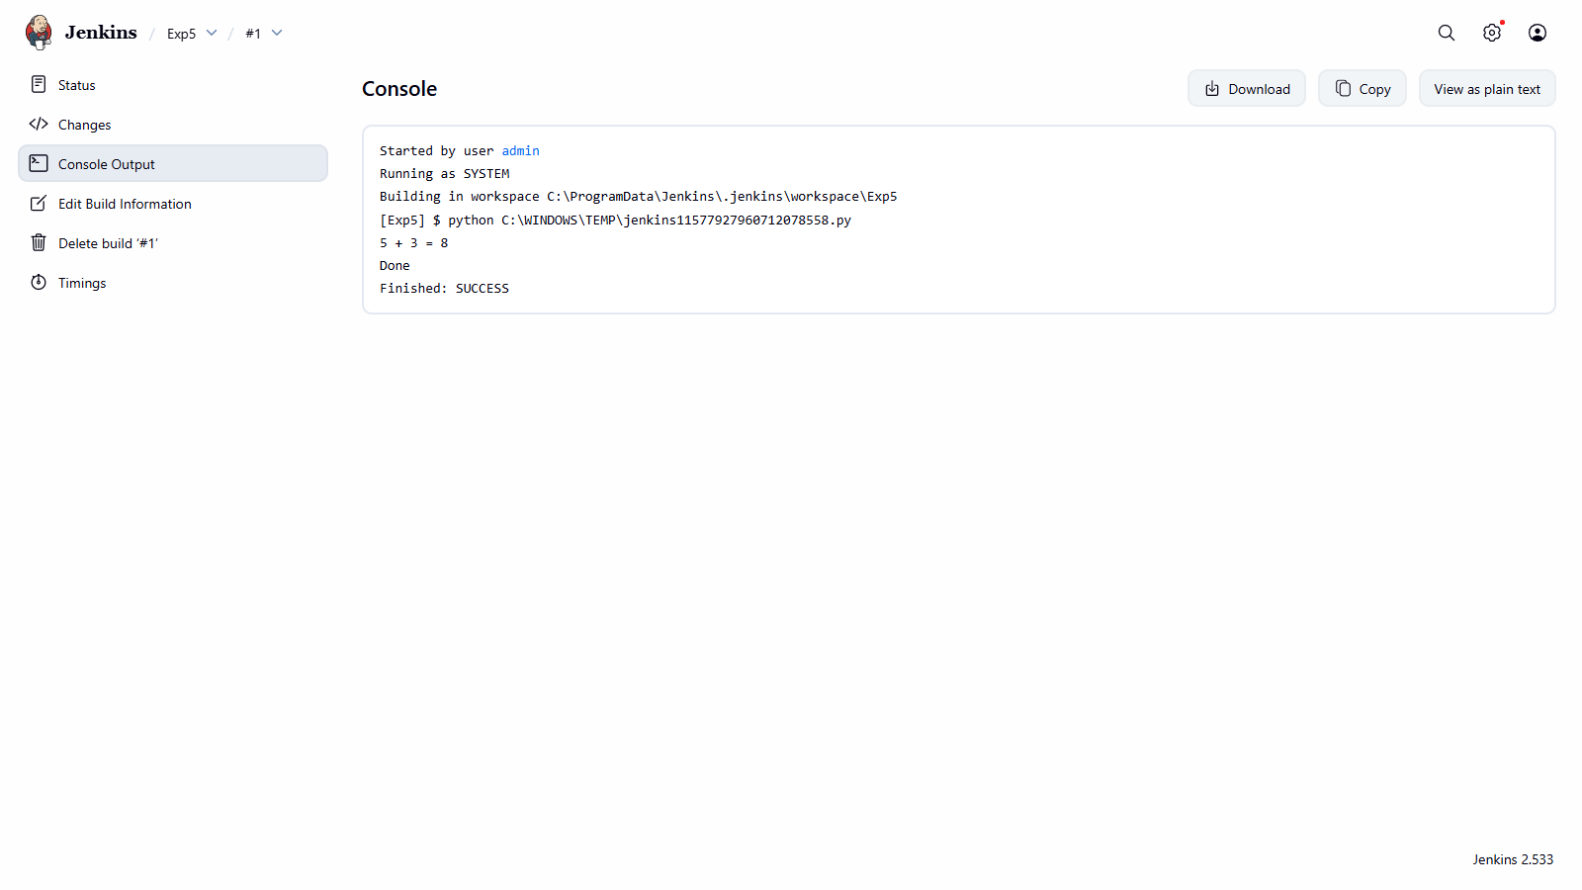

Explicit Function
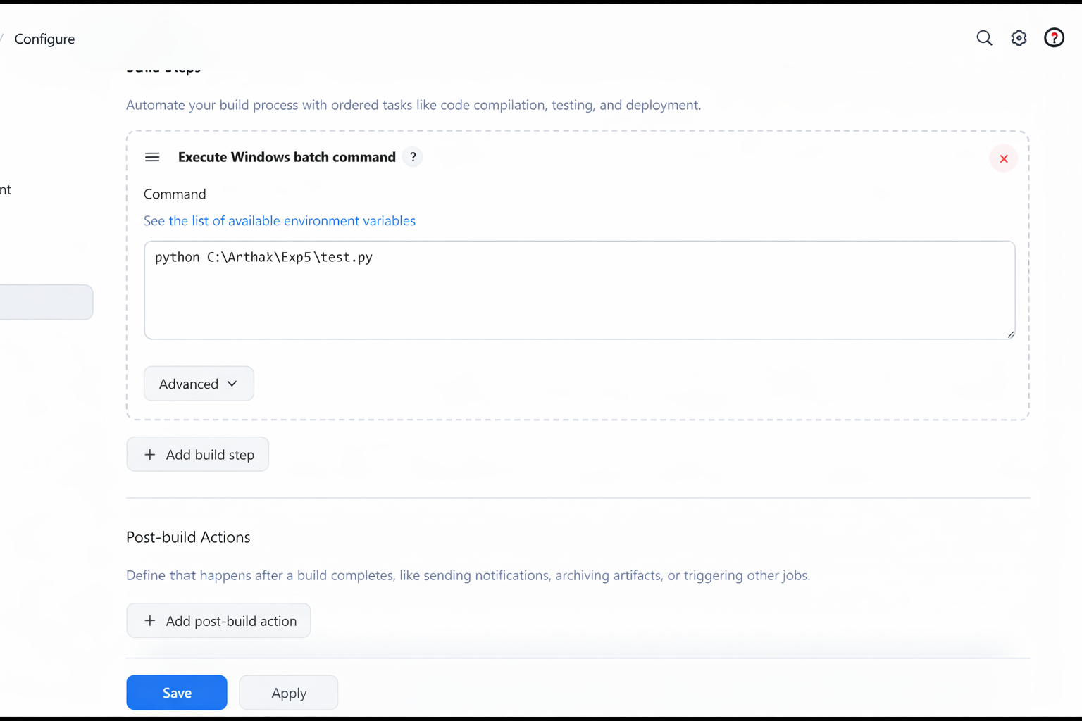

Console Output:

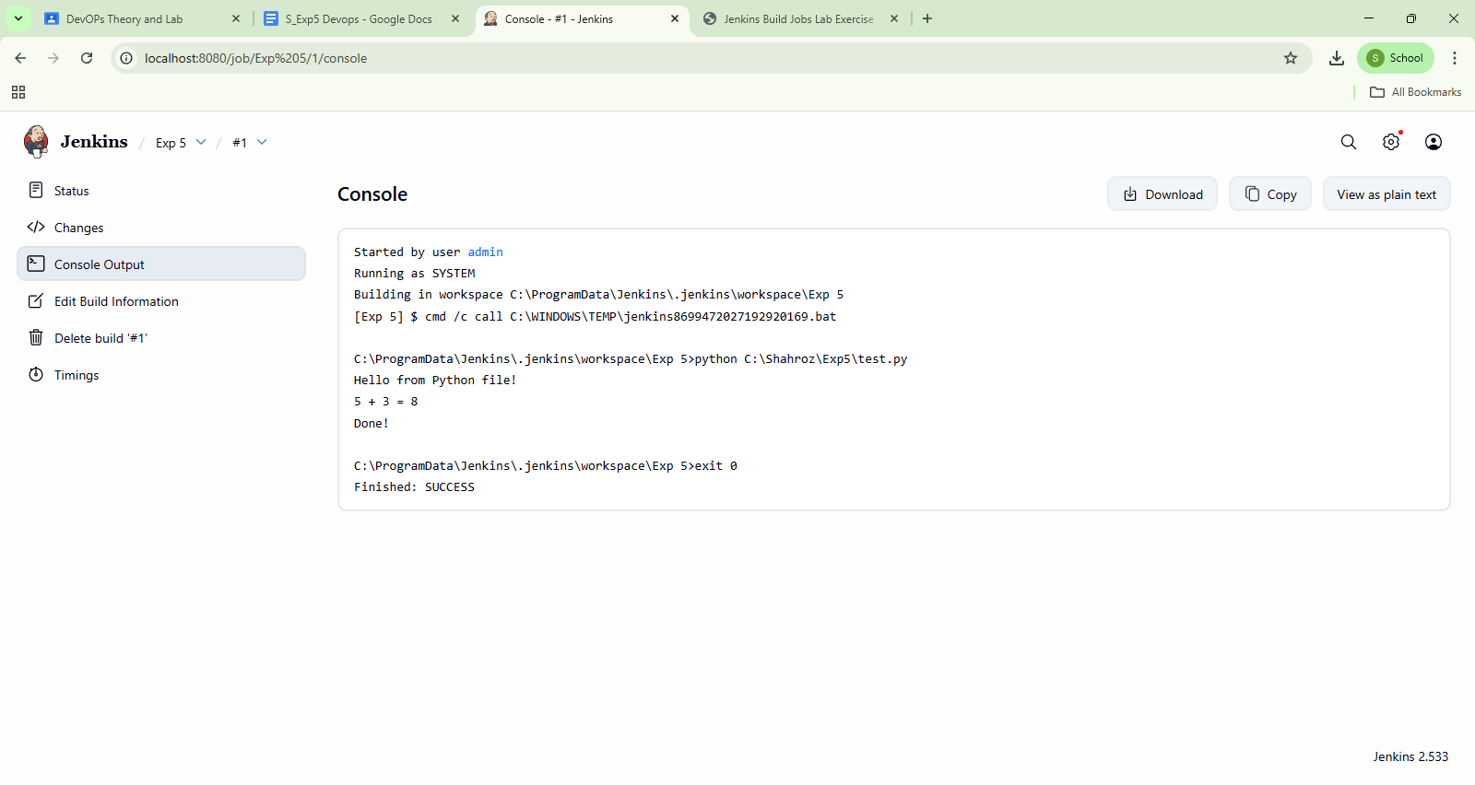
Maven
To be forked repo
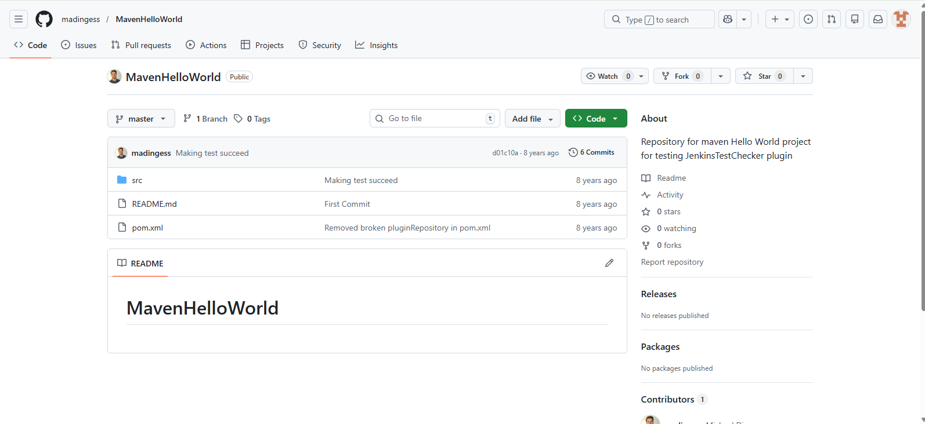

Forked repo
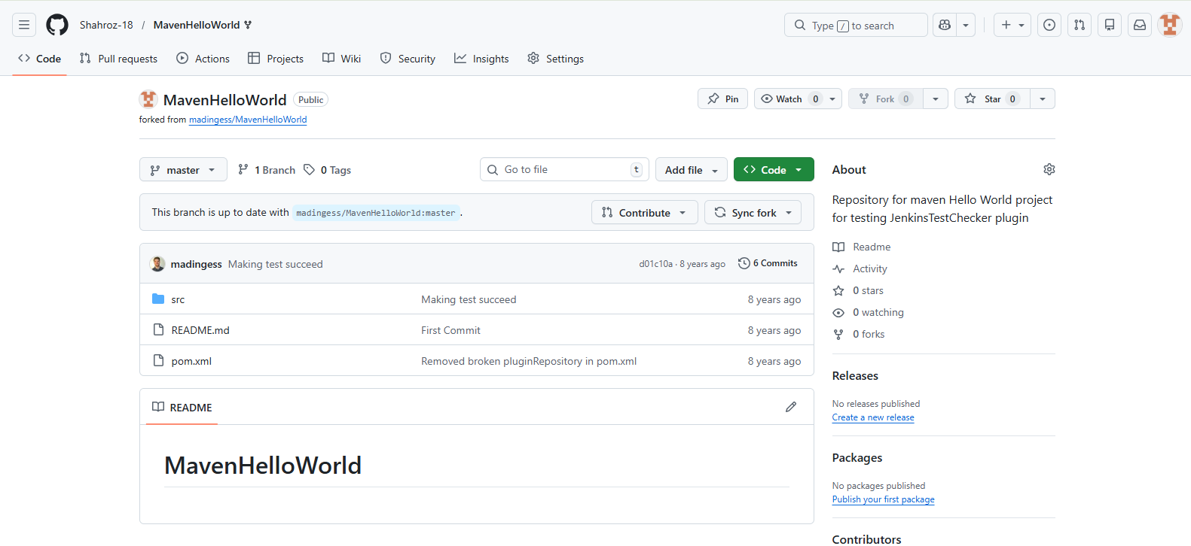
Repository URL
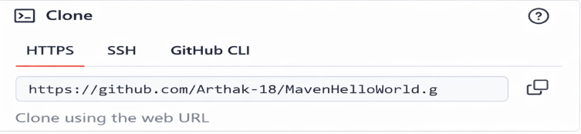
Creating a Maven Project
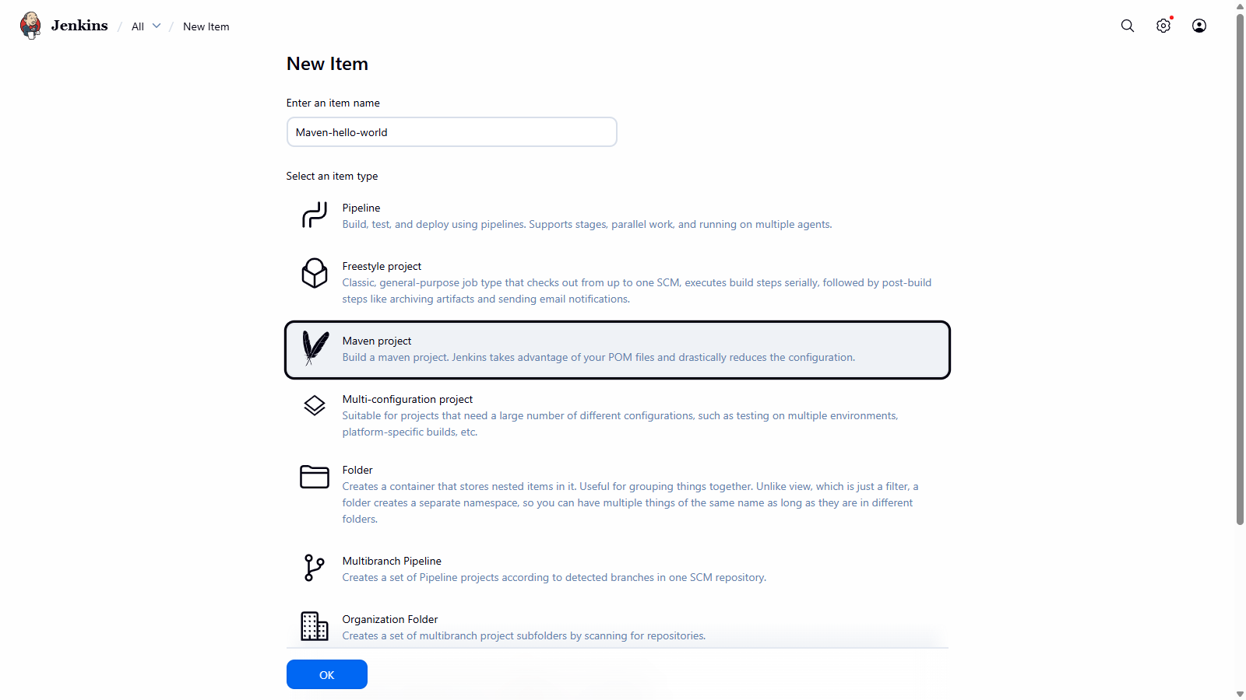
Pasting Repository URL
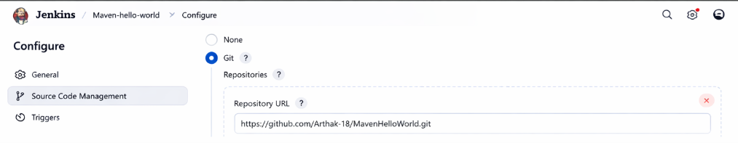
Build Root Pom
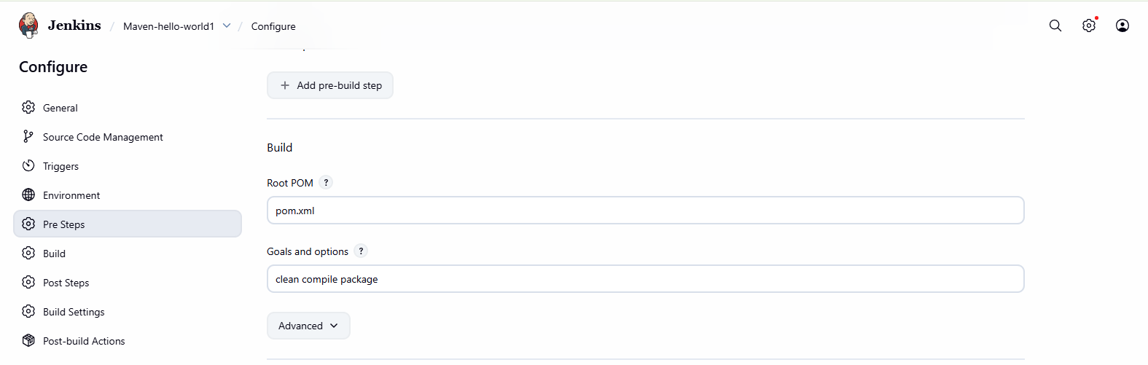

Console Output
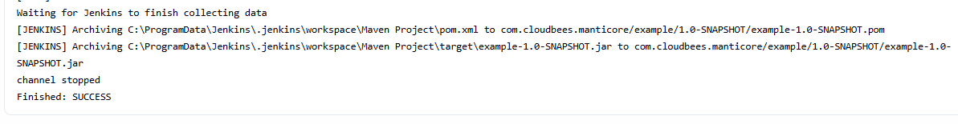
.jar file
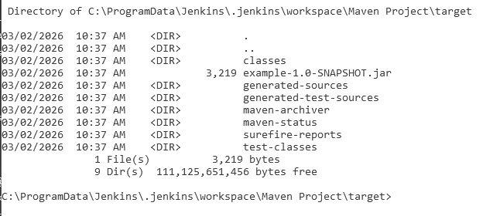
Ant Project
RPS Ant repository
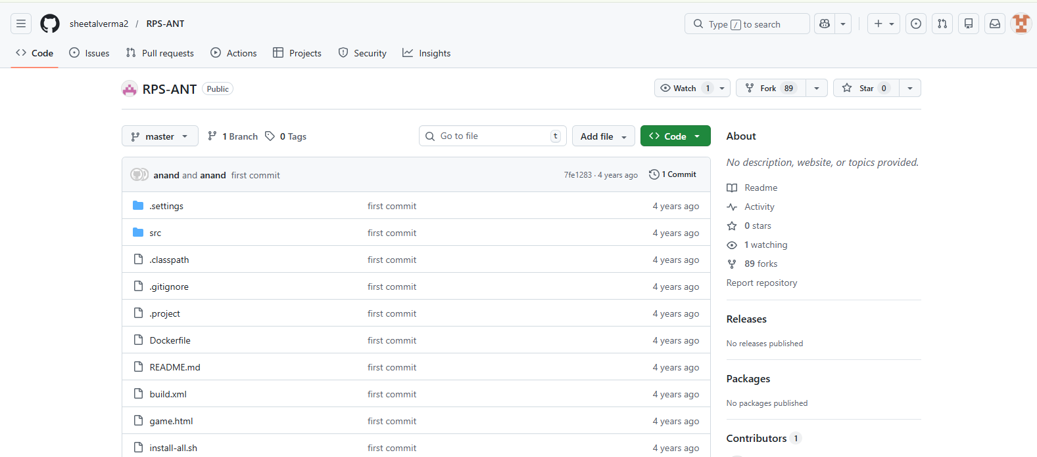

Fork Repository
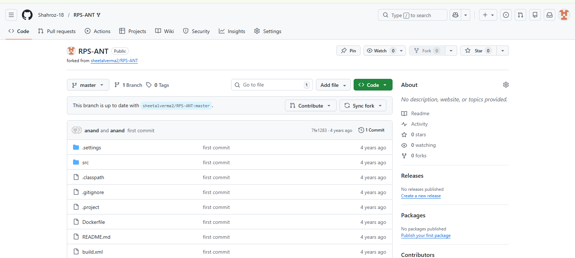

Url of github forked repository

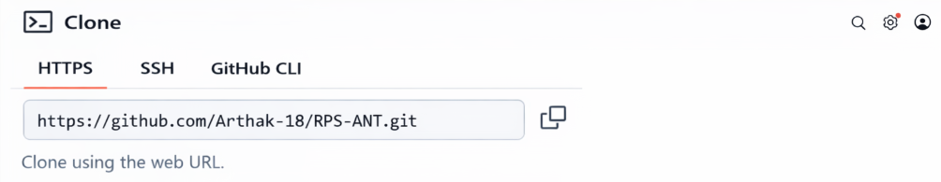
Freestyle Project
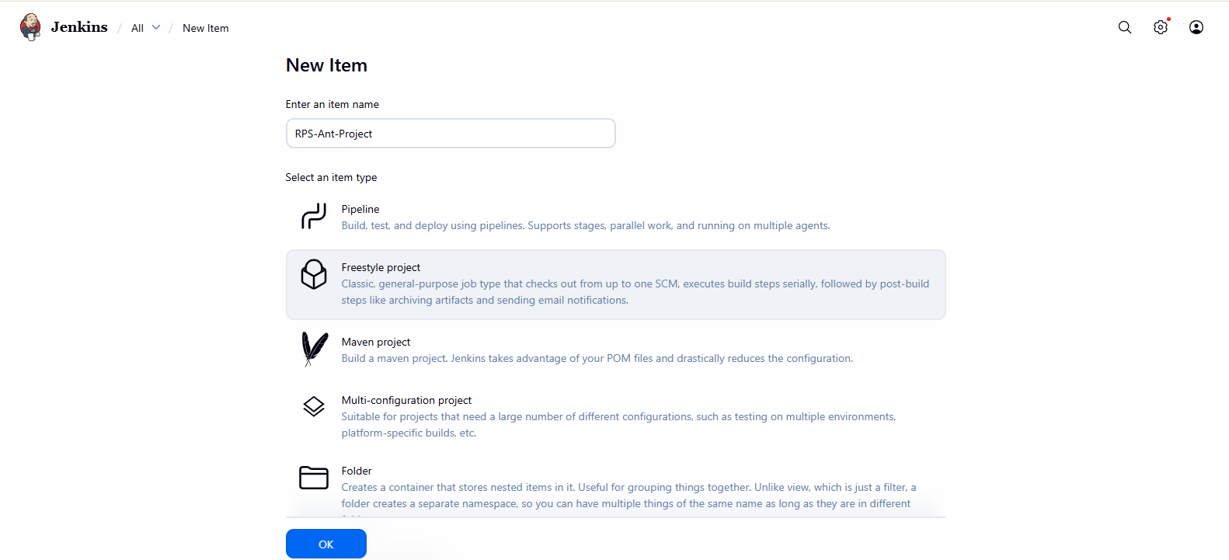

Git Repository
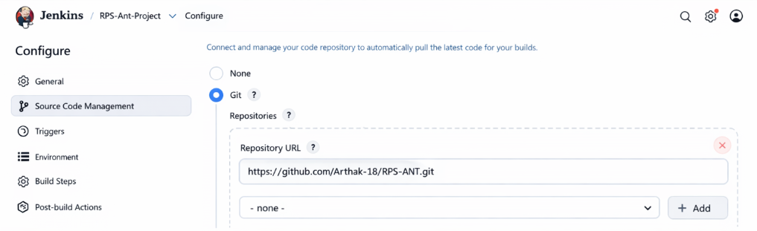

Invoke Ant
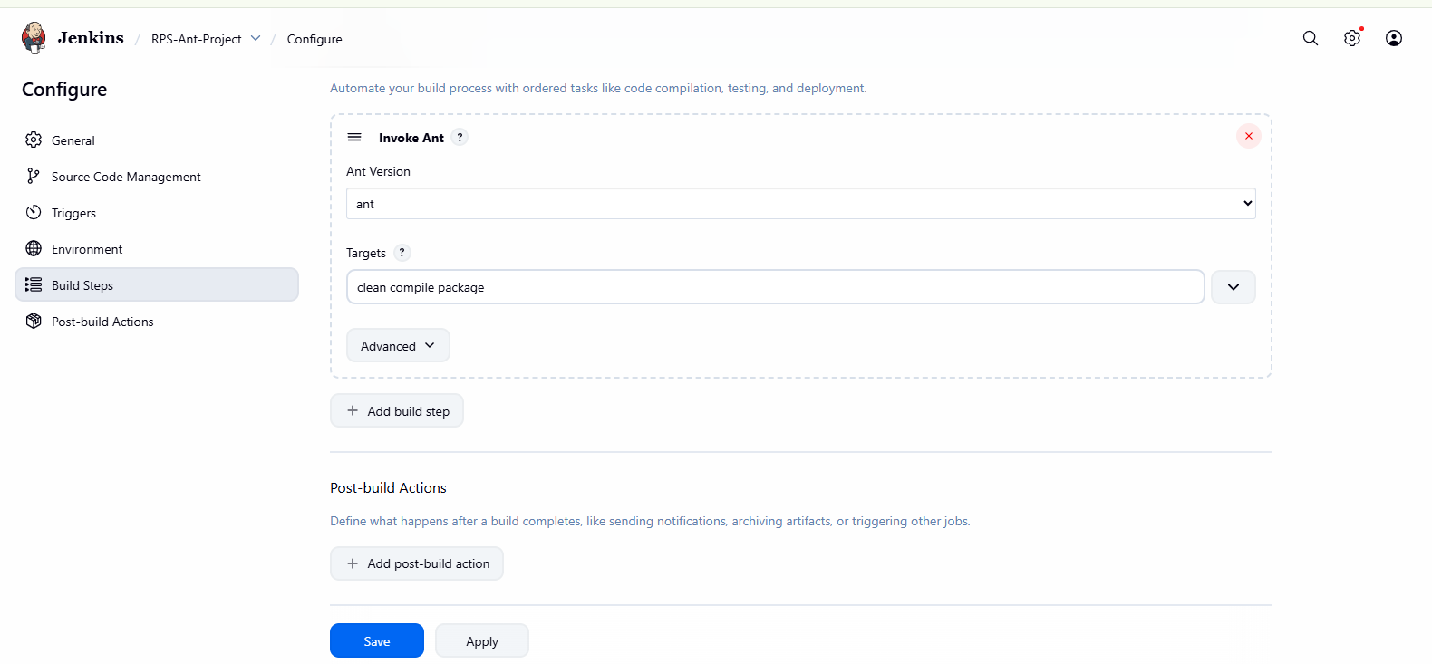

Console Output
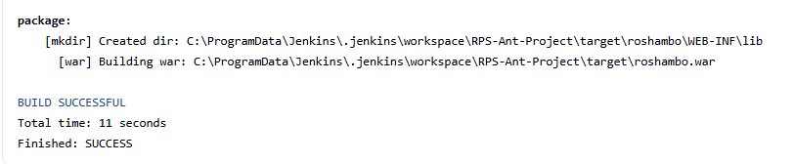
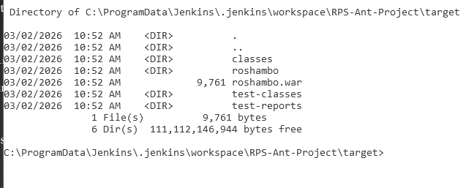
War file

